**ACCOUNTING SYSTEM**

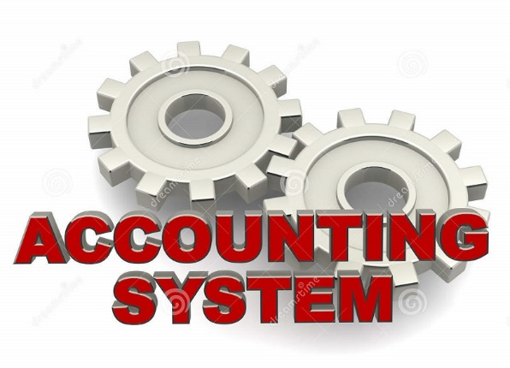

**Powered by ZeonIt**

**Content**

1. Introduction about Accounting System .
2. Manage Accounts .
3. Customers .
4. Payments .
5. Make Sale .
6. Vendor .
7. Pay Bill .
8. Transfer Money .
9. Reports .
10. Backup .
11. Item .
12. Purchase .
13. Make Journal .
14. Petty Cash

**1.Introduction about Accounting System .**

This is an Accounting Software . Accounting System products are geared mainly toward small and medium-sized businesses and offer on-premises accounting applications as well as cloud-based versions that accept business payments, manage and pay bills, and payroll functions.

**2.Manage Accounts .**

This Is Manage Account Interface.

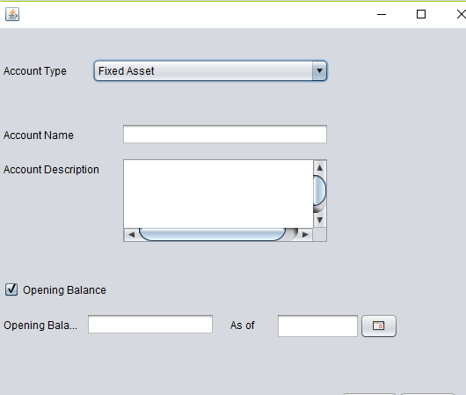

User Should Select Account type in this Combo box and after that account name , account description , opening balance and date user should enter into system.

Finally click on the save button .if you need to close this window click on the close button .

**3. Customers .**

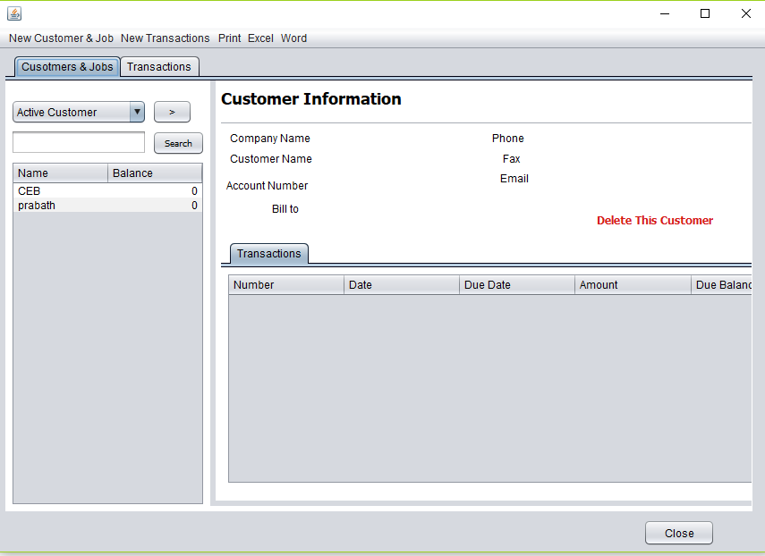

Add new customer click this label

* This is the main user interface , handle all customers .
* User can search about invoices about this user interface .
* User can get a summery about this user interface .
* This invoices summery default enable with Customer & jobs label.
* Transaction label default enable with below form .
* If we select the name in this table , we can see that customer’s information .
* You can not delete customer , if he or she has an transaction details .
* You can see transaction window in below .

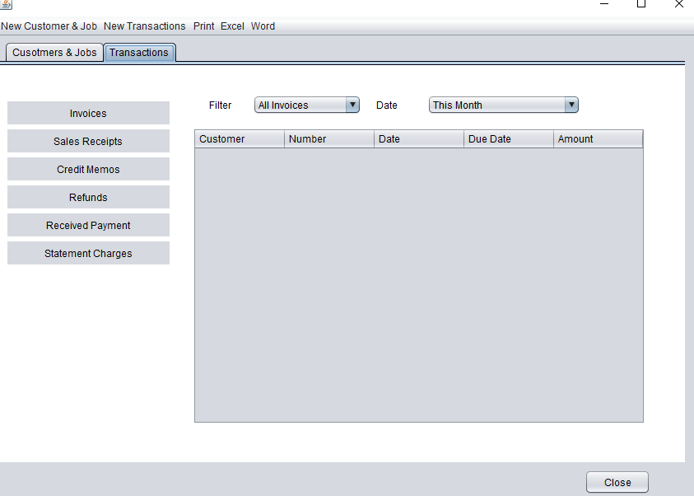

* Use can get summery about transaction in this form .
* If the user need make an new invoice click the new Customer & job .

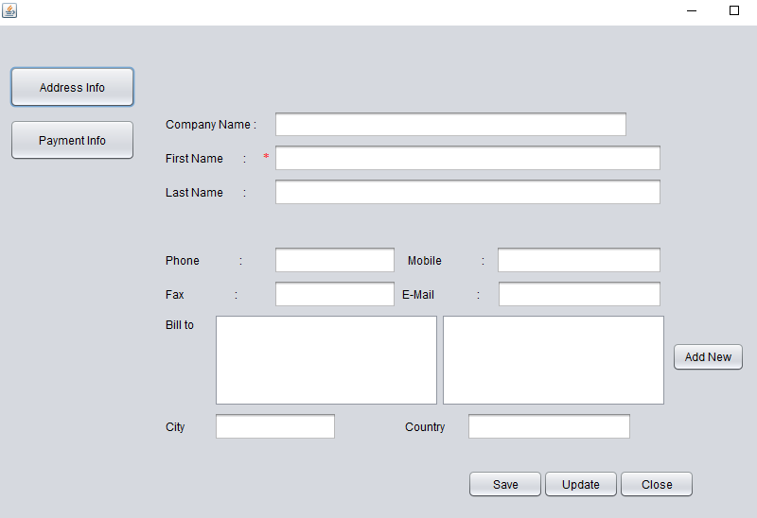

* After click new Customer & job get above user interface ..
* This form default enable with Address Info Button .
* Customer’s invoices details include in this form.
* If User entered incorrect Customer’s invoice details in to system ,user Can update it after click Update Button & enter correct details in to system.
* User can exit this form after click close button .
* After Click Payment Info button get new form we can see it below page .

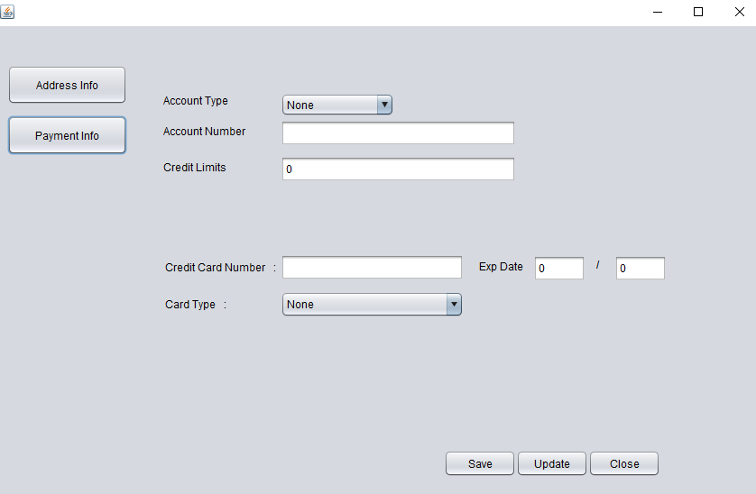

* Invoice’s payments details include this form .
* Firstly user need to select customer’s Account type .(ex-:SAMPATH ,BANK OF CEYLON,PEOPLES and etc…).
* If User input correct details in to system , click the save button . unless input correct details and after that click update button and input correct details in to the system.

1. **Payments .**

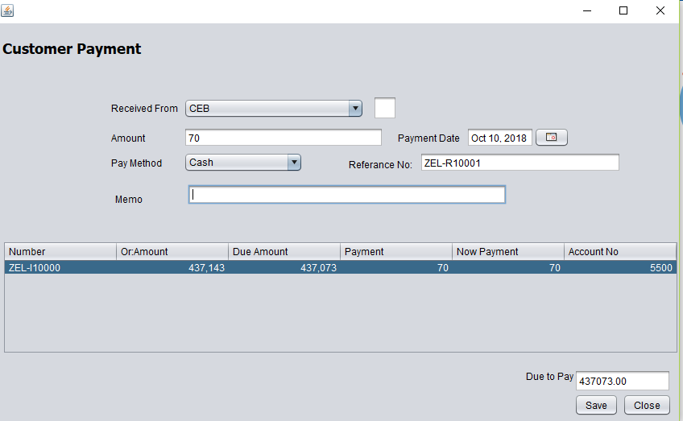

* This is Customer payments form .
* loading all invoice's appropriate customers in to Received from combo box .
* If User select the customer in combo box , auto loading all details to the table.
* If the customer has to payment to the appropriate invoice , user should include customer's new payments into the system .
* After payments , should reduce the payments amount invoice’s value. It is auto calculate by system.
* after the payments click the save button . after that new data update the database by the system .
* Customer can pay amount periodically as this method .

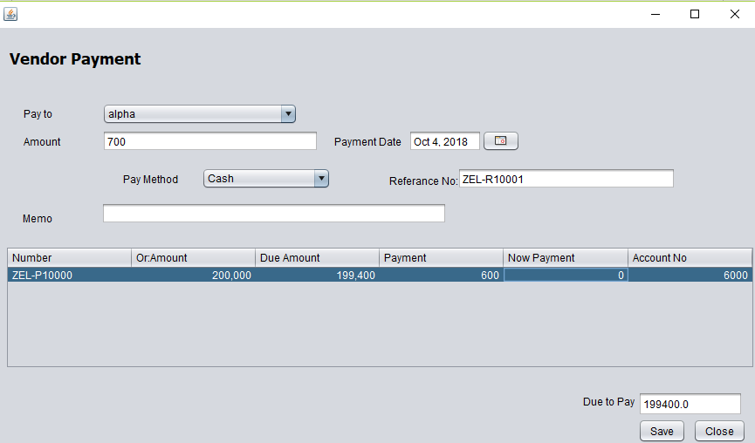

* This is Vendor payments form .
* loading all invoice's appropriate vendors in to Received from combo box .
* If User select the vendor in combo box , auto loading all details to the table.
* If the vendor has to payment to the appropriate invoice , user should include vendor’s new payments into the system .
* After payments , should reduce the payments amount invoice’s value. It is auto calculate by system.
* after the payments click the save button . after that new data update the database by the system .
* vendor can pay amount periodically as this method .

**5. Make Sale .**

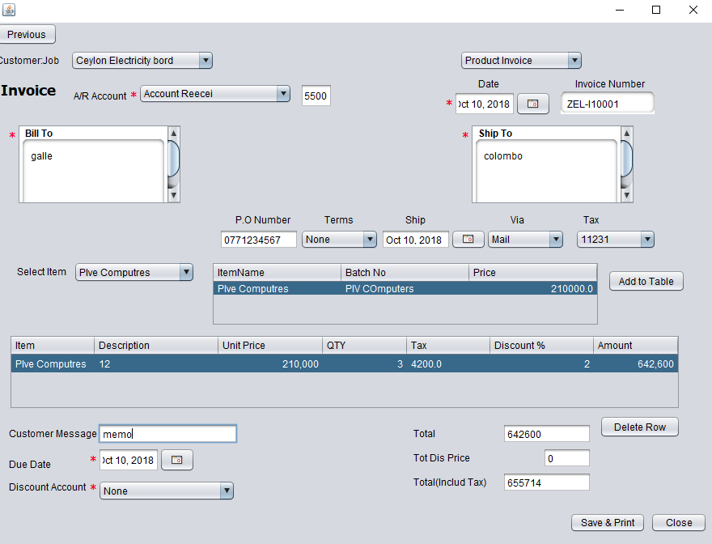

* This is the customer invoice .
* Firstly user should select customer job in above combo box .
* After that include details correctly in to the text fields .
* Select the correct A/R Account in to the combo box .
* User should include the data customer’s wish .
* User Should enter correct date into the system .
* If user need to cancel or delete items , click the delete row button .
* Finally entered Customer’s detail , click the Save & print Button after that customer can get a bill about the invoice .
* User can exit this form whenever click the close button .

**6. Vendor .**

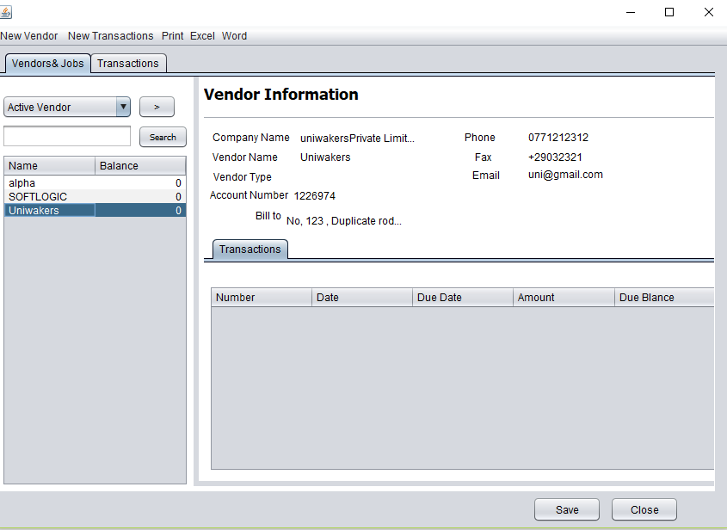

* This form As Customer form .
* This is the main user interface , handle all vendors .
* User can search about invoices about this vendor form.
* User can get a summery about this vendor invoices .
* This invoices summery default enable with Vendor & jobs label.
* Transaction label default enable with below form .

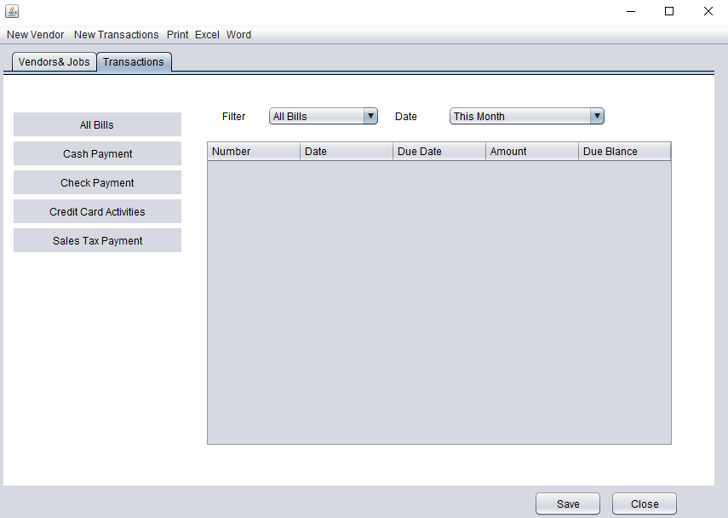

* User Can get Summery about the transactions.
* User can search about the transactions , using above combo box 's values.
* Using this form, the user can get detail about the bill payments summary ,Cash payments summary ,Check Payments summary , Credit card activities summary and Safety tax payments summary .
* If customer need to make an invoice , click the new vendor button .

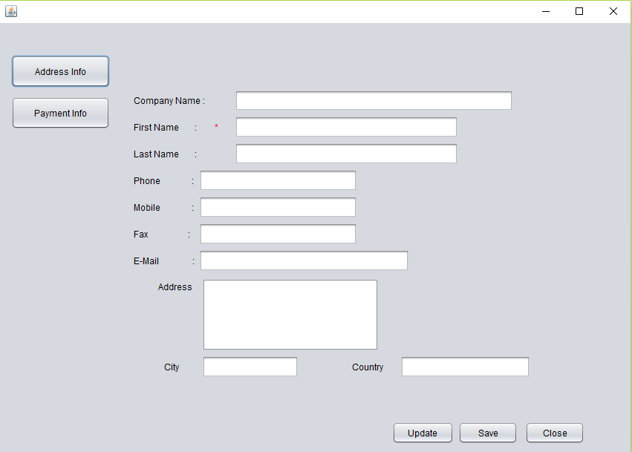

* User should fill about the Customer’s detail in this form .
* This for enable with address info button .
* Payment info button enable with blow form .

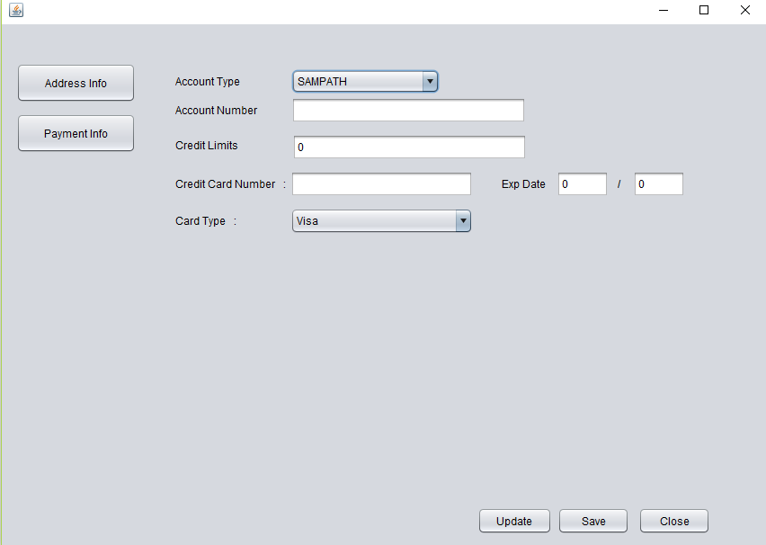

* This is the payment form about the customer invoice .
* After fill all blanks , use should click the save button .
* If user entered incorrect detail , user should get update option .
* You can exit this form click the close button .

**7. Pay Bill .**

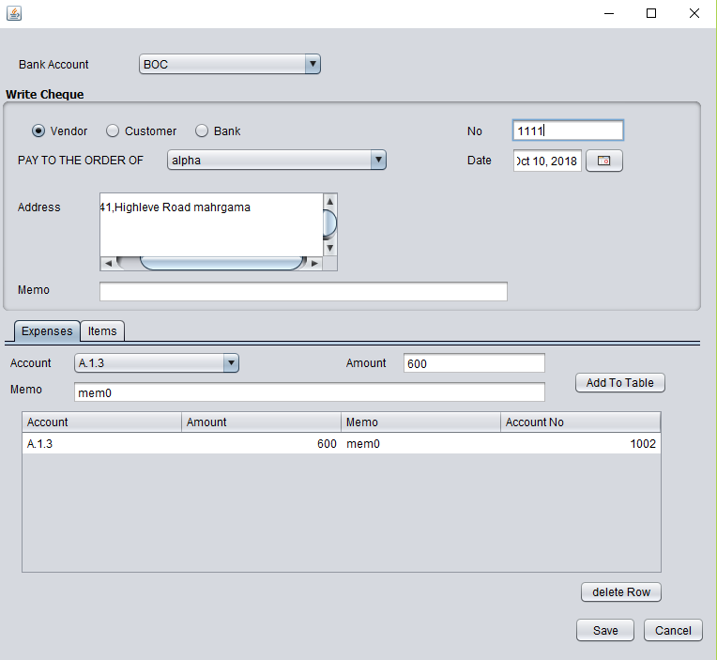

* This form use for pay for company’s bill .
* Firstly user should select type of vendors in write cheque panel .
* Secondly add check details correctly .
* After that select items label . it is auto enable with below panel .
* User should select items , appropriate for above person’s cheque detail
* After click the Expenses label you can get below form

**8. Transfer Money .**

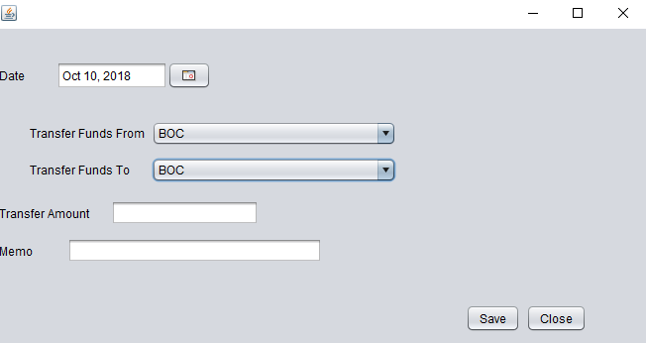

* This is transfer money user interface
* We can transfer money since one account to another account .
* Firstly select transfer date and select accounts correctly .
* After that enter transfer amount and memo .
* After that user should click the save button .
* Calculate all functionalities by system .
* If user entered detail was incorrect , please click previous button .
* You can get below form .

1. **.Reports**

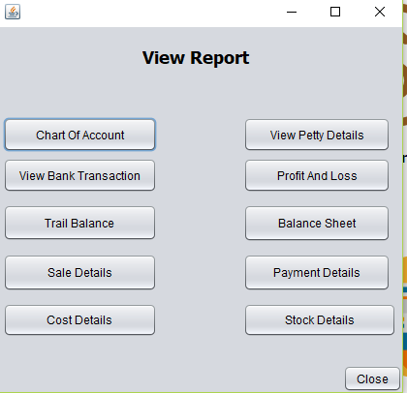

* User can get reports about Account Paper details ,Account Receivable details ,cost of good solve details , profit loss details , sales details ,Bank transaction details , petty cash details.
* You can see Account Paper detail report in below .

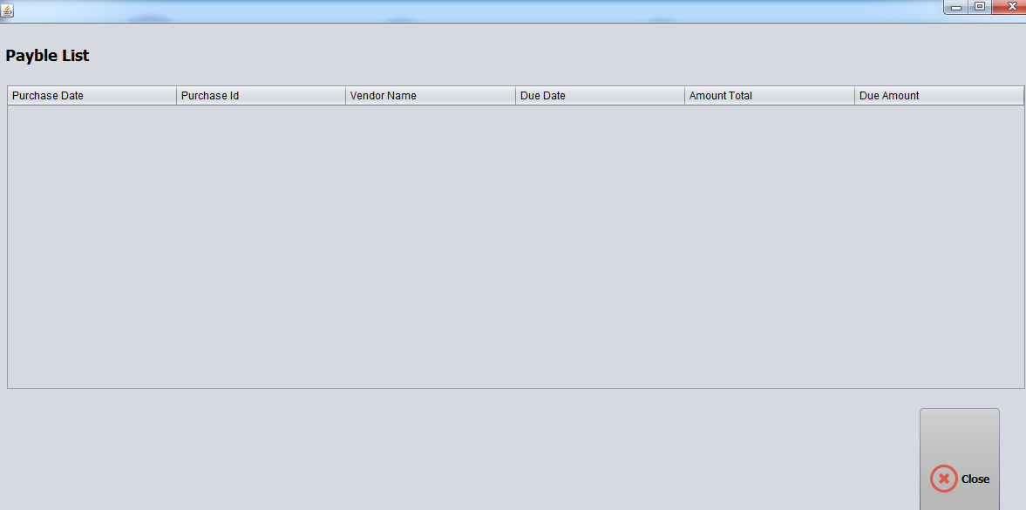

* Account Receivable report.

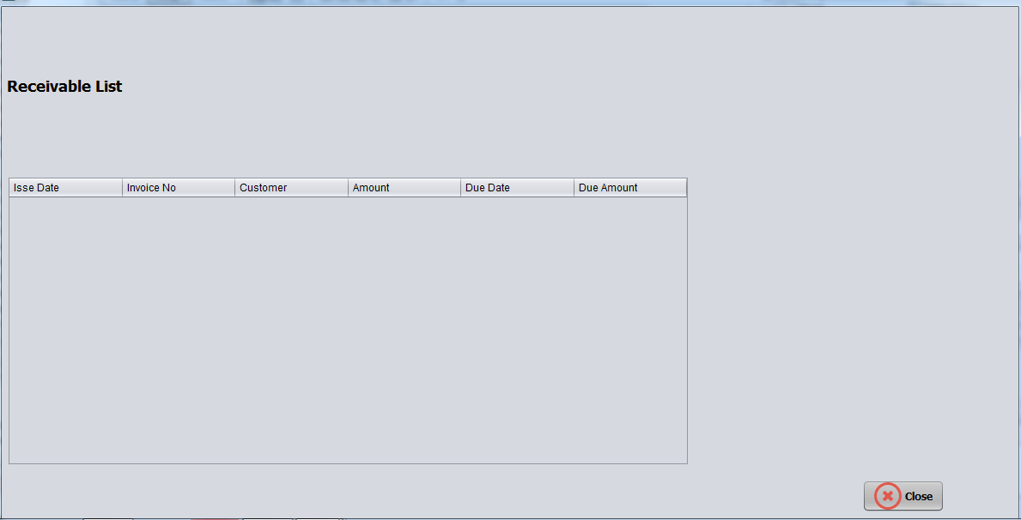

* Cost of good solve report .

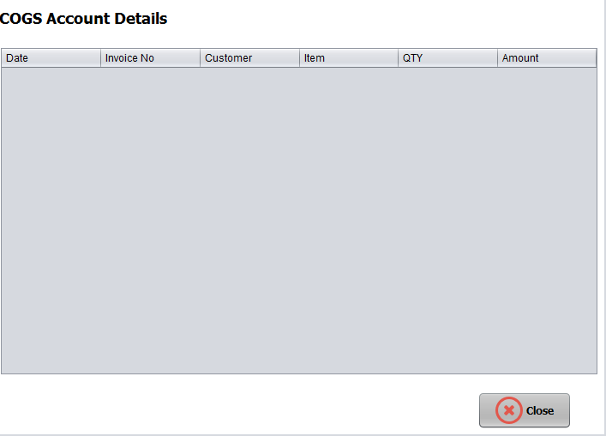

* Profit loss detail report .

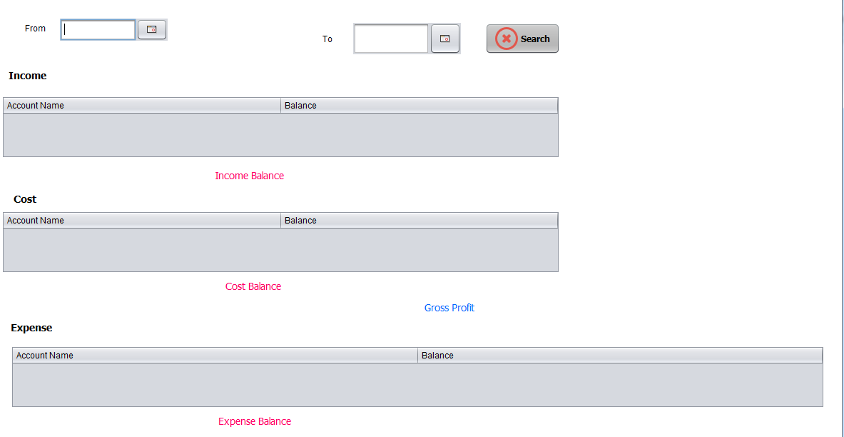

* Sales details Report .

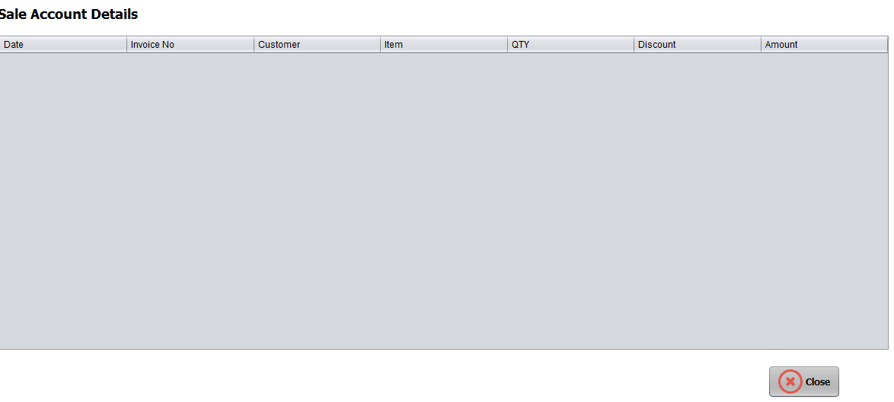

* Bank Transaction detail report .

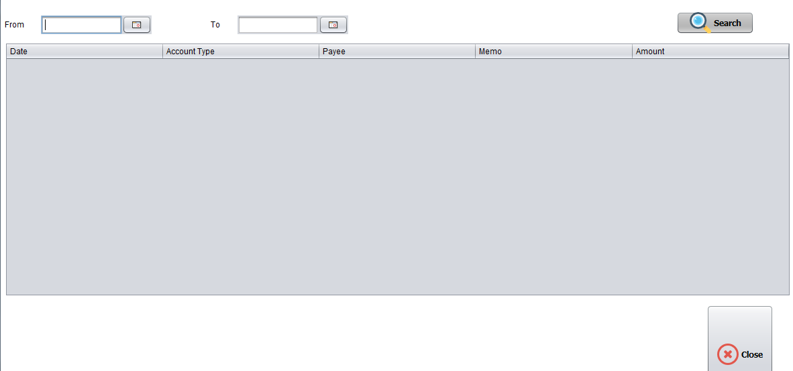

* Petty Cash details report .

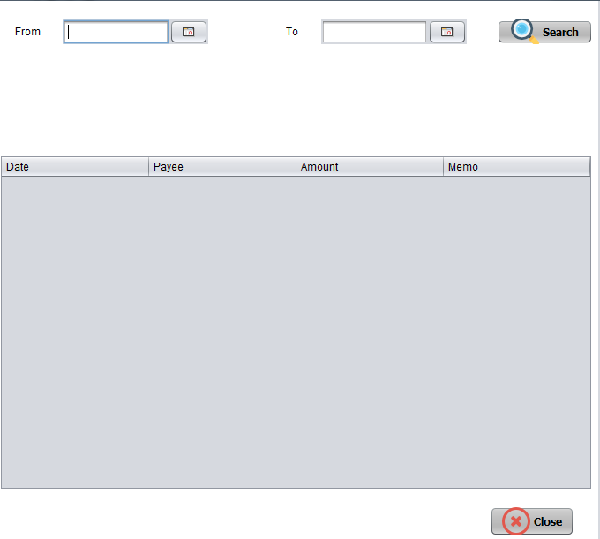

**10.Backup**

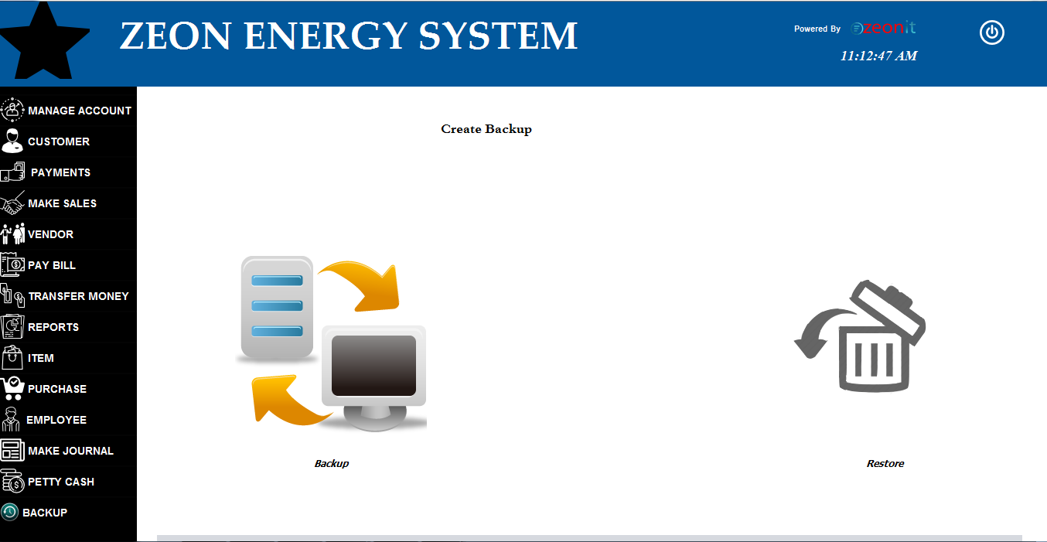

* This is Backup form .
* User can create backup using this form .

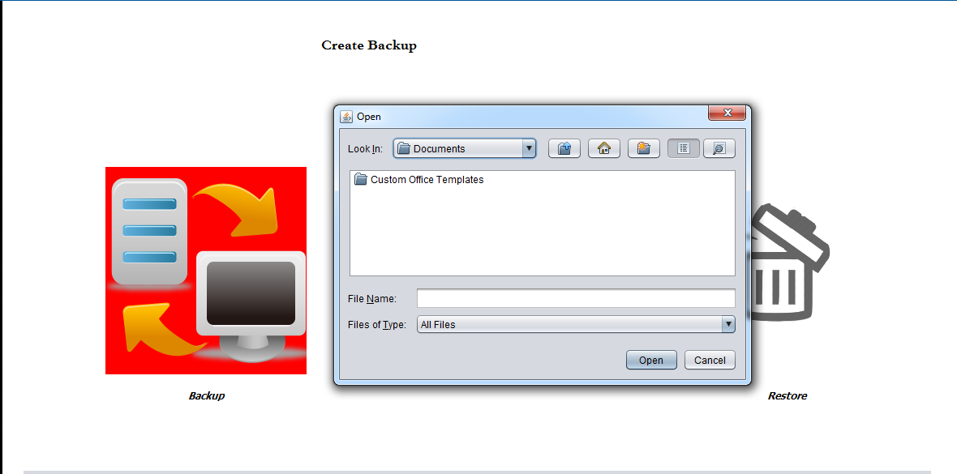

**11. Item**

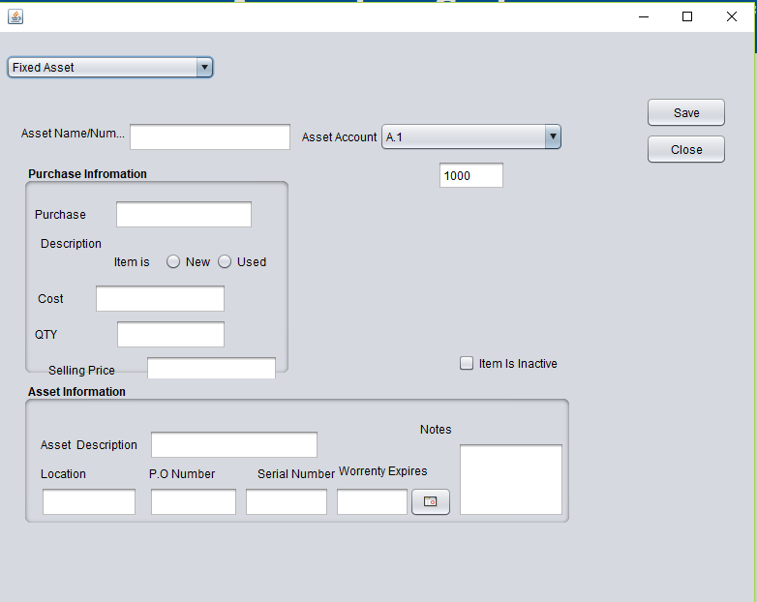

* This form auto enable with fixed asset .you can see it scroll down the combo box .
* Firstly enter asset name or number .
* After that enter purchase information in allocated panel .
* Asset information should enter below panel .
* If details are correct , click the save button .

**12.Purchase**

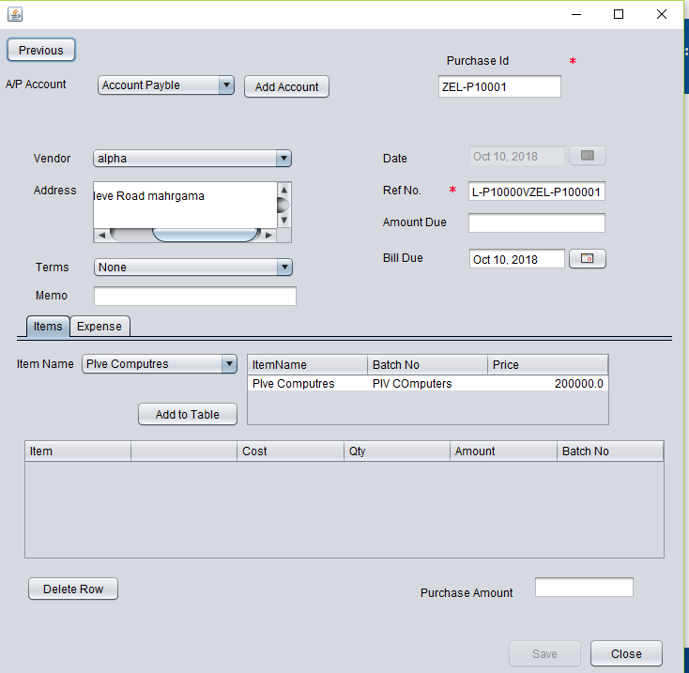

* a/p account auto load by system .
* vendor list also auto load to combo box .
* Items label default enable with below panel .
* Expenses label enable with below form .

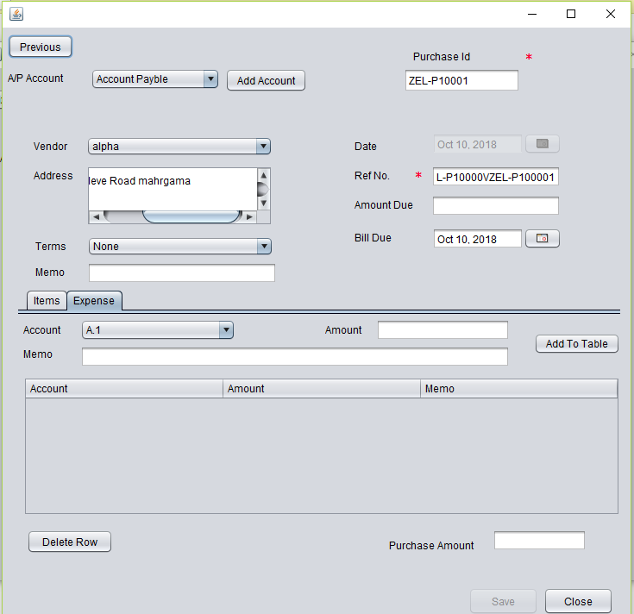

* Enter detail about expense.
* After that click save button .
* If you entered incorrect data , please select & delete selected row in the table .

**13.Make Journal .**

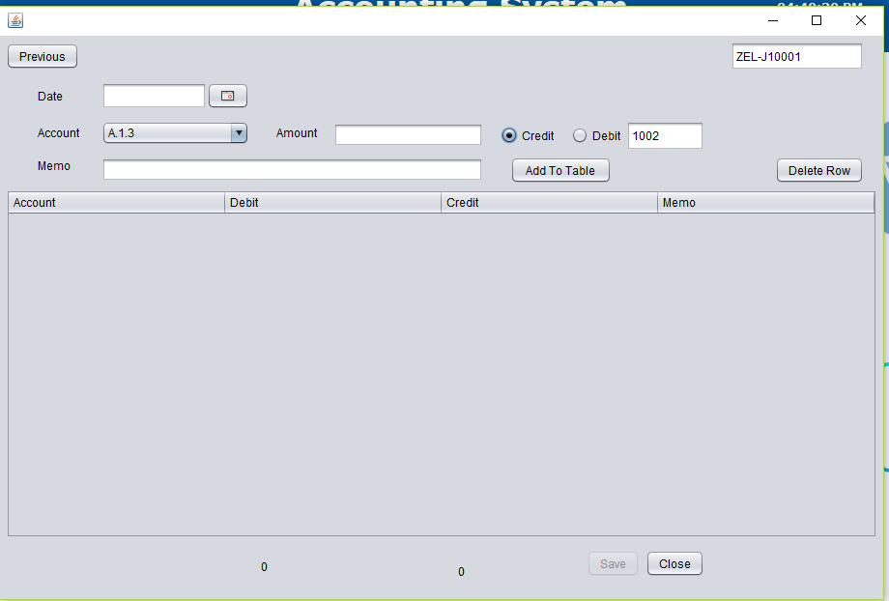

* This is the make journal form .
* All details should enter about the journal by the user .
* User should select card type in above check boxes .
* If you add incorrect data into the system , you should delete it in below table .
* If you enter all details , save button will auto enable by system

**14. Petty Cash .**

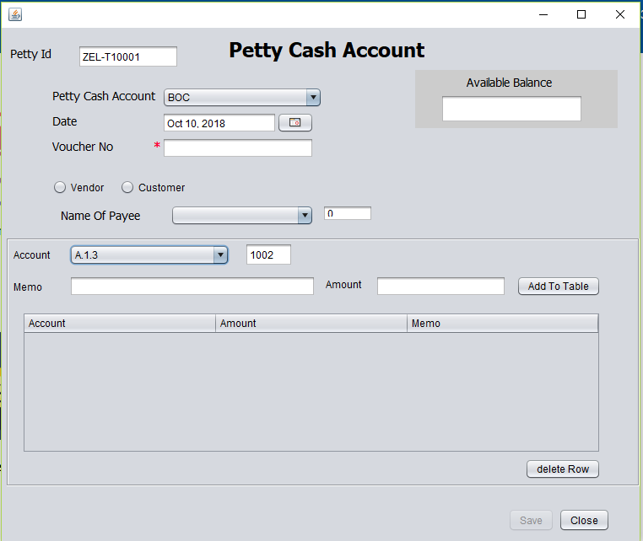

* This is petty cash form .
* Petty cash accounts will auto load to the combo box by the system .
* available balance show above in the Available balance blank text field .
* name of payee will auto loading by the system .
* Accounts will auto loading to the account combo box by the system .
* User should enter the data correctly into the text fields .
* After fill the details into the text field , please click the add to table button .
* User should select customers' type in above checkbox .
* If all data enter , please click the save button .
* If you entered data was incorrect , you can remove that data after select and click the delete row button .
* User can close this form click the close button .